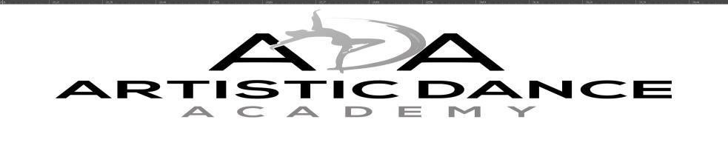

1

Calendar- Dates to Remember
Aug. 8 - Classes Begin!
Sept. 5 - Labor Day - Studio Closed
Nov. 10 - Costume Deposits Due
Nov. 23-26 - Thanksgiving Break – No Class
Dec. 19 - Jan. 6- Winter Break – No Class
Jan. 9 - Classes Resume & Costume Balance Due
Mar. 6- Recital Fee Due
Apr. 10-14 - Spring Break – No Class
May 9-May 31 – Priority Tickets Sales
May 29-Memorial Day –No Class
June 1 – General Ticket Sales
June 12-15 Picture Day Arrive at your dancer’s scheduled class time
June 23- Mandatory Dress Rehearsal; Friday, 6pm -8:30pm –Location: Columbia College - Cottingham
Theatre (1301 Columbia College Dr, Columbia, SC 29203)
June 24- Recital; Saturday 2pm and 4:30pm– Location: Columbia College - Cottingham Theatre (1301 Columbia
College Dr, Columbia, SC 29203)
- Ballet, Tap, Lyrical, Jazz & Hip Hop- 12:30pm Arrival Time
- Tutus- 1pm Arrival Time
July 10 - Summer Camps Begin
Recital Participant Fees
  - Recital Fee- $55/child due by March 6. (Recital is $15 general admission for everyone with an option to make an additional donation to support ADA. Our Recital is our one-time giant fundraiser to cover both the cost of putting on the Recital and all of our expenses that are not covered by recital fees alone).
  - Costume Fee- $75/Child due by the first week of class in January. If a student is enrolled more than one class there is an additional costume fee per class/solo (All combo classes will be required to purchase two costumes)

  - There will be a deposit amount of 50% due on November 10 and the Final payment will be due by January 9. It is imperative that you meet costume payment deadlines to ensure you have enough time to make any alterations to costumes if needed.
  - All fees/deposits for costumes, registrations, tuition etc. are non-refundable.
  - If your child enrolls after costumes have been ordered, the costume fee goes up to $80/ costume due to the high cost of shipping individual items. We cannot be responsible for costumes that may no longer be available at that time.
  - Costumes are final sale. Parents are responsible for any alterations that need to be made to the costume.
*ALL RECITAL FEES ARE TO BE PAID AT THE PARENT PORTAL. Monthly tuition should be paid at richlandrec.com no later than the 10th of each month. Auto pay for any unpaid fees runs on the 11th of every month or thereafter until the fee is collected at the parent portal, including tuition and recital participation fees. All fees must be current to participate in recital.
*There will be no costume refunds for dropped classes or withdrawals from the studio after November 10th, 2022. It is your responsibility to email us at
artisticdancecompany@gmail.com no later than November 10, 2022 if your dancer will not participate in the end of year recital.

